**PROJECT CHARTER**

*Please see the Instructions section at the end of this document.*

**Title of Research Project:**

Monitoring the urban noise environment using a distributed acoustic sensor network

**Term of Project:**

July 31st, 2017 – December 31st, 2017

**University of Calgary Researcher(s)*:**

Dr. Henry Leung, Principal Investigator, Professor, Department of Electrical Engineering, leungh@ucalgary.ca, 1-403-220-4875

Dr. Dean Richert, Postdoctoral Scholar, Department of Electrical Engineering, dean.richert@ucalgary.ca, 1-403-836-7545

**City of Calgary Partner(s):**

Nan Xie, IT Engineer 3, IT – Innovation & Collaboration – Field Mobility Solutions, [Nan.Xie@Calgary.ca](mailto:Nan.Xie@Calgary.ca), [403-268-3755](tel:(403)%20268-3755)

Colin Adderley, IT Engineer 2, IT – Innovation & Collaboration – Field Mobility Solutions, [Colin.Adderley@calgary.ca](mailto:Colin.Adderley@calgary.ca), [403-268-1047](tel:(403)%20268-1047)

Karim Hussein, Project Manager, IT – Innovation & Collaboration, Program Centre, [Karim.Hussein@calgary.ca](mailto:Karim.Hussein@calgary.ca), [403-268-2298](tel:(403)%20268-2298)

**City of Calgary Sponsor:**

Nan Xie, IT Engineer 3, IT – Innovation & Collaboration – Field Mobility Solutions, [Nan.Xie@Calgary.ca](mailto:Nan.Xie@Calgary.ca), [403-268-3755](tel:(403)%20268-3755)

**Other Partner(s):**

None

**Project Description and Statement of Work:**

*Context:* The City of Calgary is installing Low Power Wide Area Network (LoRaWAN) gateways at three sites within the city: Manchester, Shaganappi, and Forest Lawn. The LoRaWAN is an integral component towards developing the City of Calgary's Industrial Internet of Things (IoT) ecosystem. The planned infrastructure will enable bi-directional radio communication between gateways and potentially thousands of battery operated devices within the coverage area. The nature of the communication is low-bandwidth with a multi-kilometer range in a star topology (single hop communication between end-users and the gateway). The low-bandwidth communication means that devices in the network can operate for years on a single battery charge. As such, LoRaWAN simplifies sensor network deployment and maintenance.

The City of Calgary has put forth a call for proposals, in partnership with Urban Alliance and the University of Calgary, for research related to the planned LoRaWAN infrastructure. It is within this context that we have prepared this letter of intent.

*Background:* Unwanted noise, or noise pollution, is a persistent problem for residents and animals that reside in an urban environment. In a city such as New York, it has been estimated that 9 in 10 people are exposed daily to levels of noise exceeding international guidelines [1]. The negative health effects of excess noise are well-documented. Routine activities such as sleep, social interactions, and relaxation are negatively impacted by noise pollution. Noise pollution is also implicated in long-term health effects such as hearing loss, psychological and cognitive disorders, high blood pressure, and cardiovascular issues [2]. For these reasons, cities institute so-called noise codes [3]. To avoid violations of this code, noise assessments are performed by inspectors or consultants who physically go to the site of interest to take measurements. The assessment findings determine what noise mitigation actions should be taken and, if necessary, consequences for a violation. However, continuous noise monitoring is rare. Indeed, noise assessments are mostly complaint driven or only performed at the inception/completion of a new project. For this reason, city officials have a very limited understanding of the acoustic environment and this makes data-driven policy decisions and/or rapid responses impossible.

Acoustic signals in an urban environment are not only loud, but they are also rich with information about the day-to-day happens within the environment. For example, sophisticated signal processing techniques allow for the classification of acoustic sources [4]. Being able to differentiate between acoustic signatures from cars versus construction sites versus a person in distress could inform city officials on the best response. Also, acoustic signatures are highly correlated with other events. Therefore, acoustic measurements could be used as a surrogate sensor for measuring traffic congestion [5], occupancy of a room [6], etc. However, monitoring on a one-time basis and at a specific site does not provide the spatial and temporal resolution necessary to take advantage of acoustic signals in these ways.

A network of acoustic sensors connected via the LoRaWAN communication infrastructure is a promising solution towards expanding our understanding of the urban noise environment. In fact, acoustic monitoring is perfectly suited for a LoRaWAN application [7] because the sensors are low-cost (allowing deployment of many sensors), low-power (minimizing maintenance), easy to install/are minimally invasive, and generate light-weight data to conform to communication bandwidth constraints. These properties combine to allow sites, which can scale to the thousands, to be continuously monitored without a large cost or staff overhead.

There are many case studies relevant to this research proposal. New York University is currently developing an acoustic sensor network. The main goal of this large-scale project, called SONYC (Sounds of New York City) [8], is to develop an accurate description of the noise environment in New York City which will be used for data-driven decision making and rapid response. Many other cities are also embarking on such projects [9,10]. Another relevant project, which highlights an interesting use-case of acoustic data, is the decible.LIVE [11, see white paper] platform. This platform uses acoustic data to create smart contracts between noise level violators and residents. Financial payments from the violator are automated to residents when noise levels exceed a threshold.

*Project Summary:* In the proposed research we will deploy LoRaWAN enabled acoustic sensing units in a region of interest (high traffic/pedestrian area, construction site, etc.) within the coverage area of one of the LoRaWAN gateway sites. The locations for the sensor units will be determined with feedback from a City of Calgary subject matter expert, but multiple deployments can also be tested. Acoustic data will be processed in-situ on the sensor unit and then transmitted to the LoRaWAN gateway. Data that is transmitted to the gateway will be stored in a cloud database, analyzed, and made available to clients. The main objectives of this cyber-physical system are (i) continuous and large scale acoustic noise reporting, (ii) to develop a suite of data analysis tools to locate, classify, and correlate acoustic signals, (iii) deliver a model to characterize the noise environment and identify noise patterns, and (iv) provide automated and meaningful dashboard summaries of the data to enable data-driven city planning decisions or, if necessary, rapid and intelligent dispatch of human resources.

Each sensor unit will consist of a category 3 acoustic sensor (20Hz-20kHz, 50-100dBA with at least 3dBA accuracy), a LoRa radio transmitter/receiver, on-board data processing capabilities, and a battery. A category 3 sensor does not meet the standards for enforceable acoustic monitoring but allows for large scale deployment due to its low price. Figures 1 and 2 illustrate the components of the proposed system.

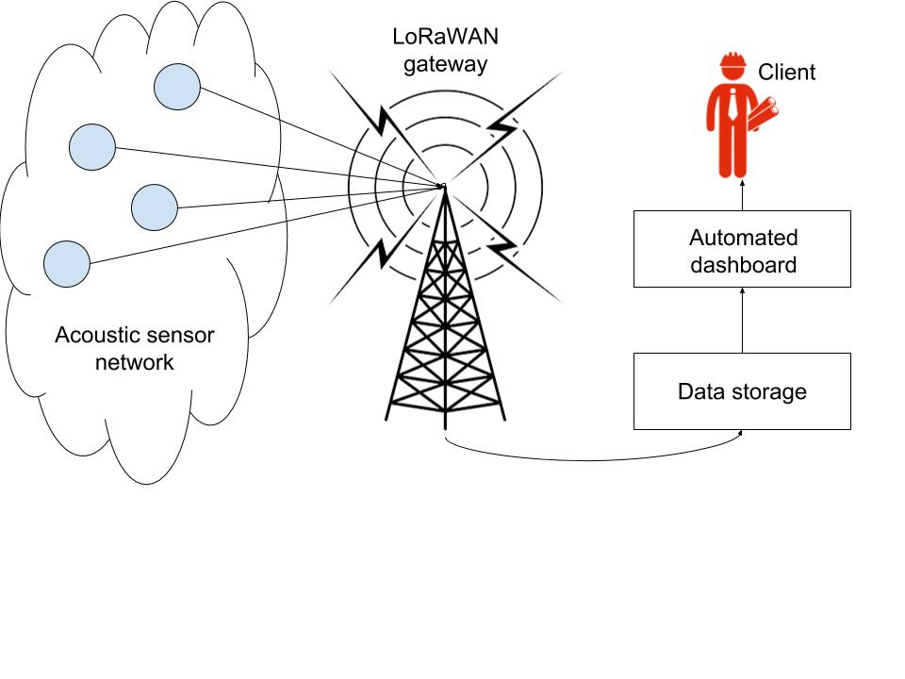

Figure 1: Overall system architecture.

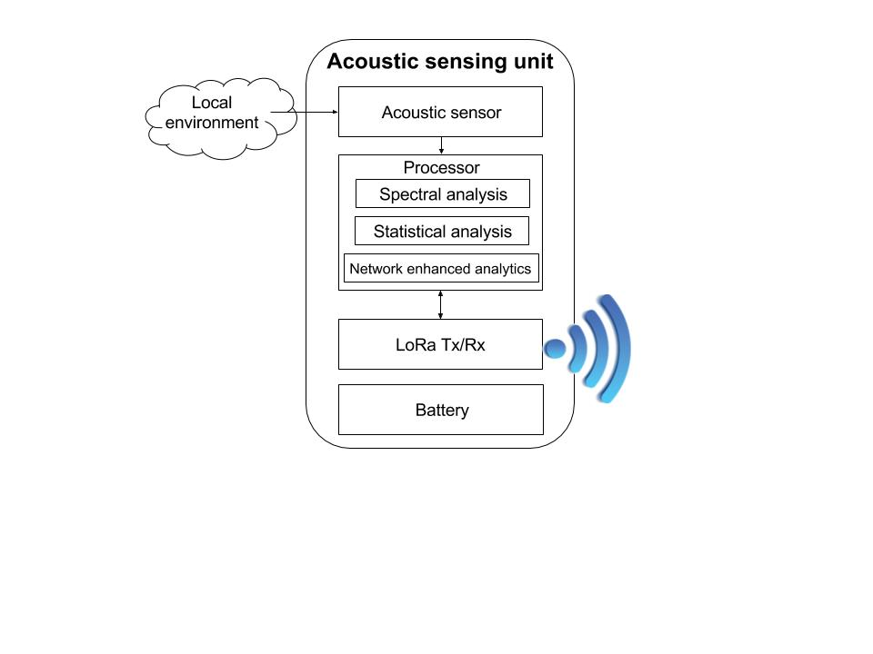

Figure 2: Individual acoustic sensing unit

An innovative component of the proposed project is enabled by the on-board processor. The on-board processing capability allows the sensor unit to collect data at a higher bandwidth than is supported by the LoRaWAN communication protocol. As a simple example, the mean, variance, and other statistics of a high-density data stream can be computed in-situ while only the metadata is actually transmitted to the gateway. We will also consider more sophisticated local processing algorithms where individual sensor units will learn classification models based on their local data, and incorporate model parameters from neighbouring sensors to refine their classification capabilities. This type of network-enhanced data analytics is an active area research and LoRaWAN makes its implementation possible.

The metadata that is eventually transmitted to the gateway will be stored in a central database. Long-term and large scale data trends must be extracted from data residing in the central database, whereas short-term and local data trends can be identified at the sensor unit level. We will use state-of-the art machine learning and distributed processing methods to analyze this vast data set [12]. Some of the proposed analysis and technologies that will be tested include:

* Outlier detection using one-class support vector machines [13] to detect anomalous signals.
* Correlation of acoustic data with other City of Calgary data sets (noise complaints, weather, emergency vehicle dispatch, etc.) using principal component analysis and regression [14].
* Acoustic distribution modeling using maximum entropy models [15] to account for sparse and noisy data sets.
* Network enhanced classification using distributed processing methods [16].

Using the spatial configuration of the sensor network, we will also test the feasibility of locating sound sources in terms of both direction and distance. Given the communication constraints of the LPWAN, only stationary and constant sound sources will be considered in this project. Experiments with multiple network configurations can be used to determine the optimal sensor deployment for this purpose.

Regarding privacy and security, the system will not have the capability to identify individuals or record conversations. The bandwidth limitation of the LoRaWAN communication protocol prevents conversation data to be transmitted to the gateway. Moreover, the physical amount of memory on the sensing unit will be insufficient to store conversation data.

*Summary of Deliverables:* Here we summarize the key deliverables of the proposed research.

* 15 acoustic sensing units (with LoRa Tx/Rx, acoustic sensor, battery, and on-board processor)
* Calibration of each unit with respect to a known sound source in a controlled environment (i) before deployment and (ii) after the units have been collected from the field.
* Deployment of sensing units (with consultation from City of Calgary subject matter experts). Multiple locations may be considered if time permits.
* Real-time data reporting to LoRaWAN gateway
  + ~ 1 successful packet transmission per 10s per sensing unit.
  + Each packet (~10B) will contain:
* total noise level over a 1s integration window
* estimated primary source of acoustic emission (i.e., car horn, siren, person)
* anomaly alert
* spectral information (e.g, dominant frequency band)
* time stamp
* reserve bits for to-be-determined data
* Data storage in OGC format on cloud database
* Model for classification of acoustic sources for in-situ processing on sensor nodes
* Data visualization and automated dashboard tool for real-time mapping of noise levels and other statistics
* Spatial and temporal model of average acoustic emissions within the study area and comparison of these models to Smart City indexes.
* Report on the performance of the deployed sensor network including a set of proposed improvements and future directions

*Communication with LPWAN team*: Monthly meetings will be held between the University of Calgary Researchers and the City of Calgary LPWAN team. These meetings will be used to discuss the progress of the project and potential risks.

*Benefits to the City of Calgary:* Referring to the City of Calgary’s 6 Smart City Pillars, the proposed research is most relevant to the Smart Living and Smart Environment pillars. This proposed research will aim to improve the quality of life of city residents through noise pollution monitoring which in turn will inform urban planning, policy development, and noise code enforcement. Also, the proposed sensor network will reduce costs to the city by limiting the need to dispatch inspectors to carry out noise assessments. As another benefit, the project participants will become experts on the City of Calgary IoT ecosystem which are needed to sustain IoT development. Finally, the project will showcase the city's investment to the Smart City mandate and garner citizen support.

*Broader Impact:* Most importantly, we view this proposed research as a first-step towards the deployment of a city-wide acoustic sensing network which would have far reaching impacts on city operations.

In addition, the methods and results of this research will apply to other Smart City initiatives. Acoustic data holds valuable information about the condition of machines, including bus engines, pumps, generators, and electric motors [17]. The lessons we will learn from this research can be applied to the deployment of acoustic sensors for monitoring such city assets. The proposed research will also improve safety by permitting intelligent dispatching of peace officers. Anomalous noise signals could be correlated with persons in distress, acts of vandalism, or gunshots [18]. During nighttime hours, when there are few bystanders to report such incidents, peace officers could be dispatched to the location of interest. Finally, it would be interesting to incorporated citizen data (for example, noise levels detected by smartphones) to improve the resolution of the acoustic network [19].

*References:*

1. Neitzel, Richard L., et al. "Exposures to transit and other sources of noise among New York City residents." *Environmental science & technology* 46.1 (2011): 500-508.
2. Passchier-Vermeer, Willy, and Wim F. Passchier. "Noise exposure and public health." *Environmental health perspectives* 108.Suppl 1 (2000): 123.
3. “Bylaws related to noise.” [www.calgary.ca/CSPS/ABS/Pages/Bylaws-by-topic/Noise.aspx](http://www.calgary.ca/CSPS/ABS/Pages/Bylaws-by-topic/Noise.aspx). Accessed 18 May, 2017
4. Stowell, Dan, et al. "Detection and classification of acoustic scenes and events." *IEEE Transactions on Multimedia* 17.10 (2015): 1733-1746.
5. Chen, S., Z. P. Sun, and B. Bridge. "Automatic traffic monitoring by intelligent sound detection." *Intelligent Transportation System, 1997. ITSC'97., IEEE Conference on*. IEEE, 1997.
6. Dong, Bing, and Burton Andrews. "Sensor-based occupancy behavioral pattern recognition for energy and comfort management in intelligent buildings." *Proceedings of building simulation*. 2009.
7. Adelantado, Ferran, et al. "Understanding the limits of LoRaWAN." *arXiv preprint arXiv:1607.08011* (2016).
8. “SONYC Sounds of New York City." <https://wp.nyu.edu/sonyc/>. Accessed 18 May, 2017
9. Pham, Congduc, and Philippe Cousin. "Streaming the sound of smart cities: experimentations on the SmartSantander test-bed." *Green Computing and Communications (GreenCom), 2013 IEEE and Internet of Things (iThings/CPSCom), IEEE International Conference on and IEEE Cyber, Physical and Social Computing*. IEEE, 2013.
10. Santini, Silvia, Benedikt Ostermaier, and Andrea Vitaletti. "First experiences using wireless sensor networks for noise pollution monitoring." *Proceedings of the workshop on Real-world wireless sensor networks*. ACM, 2008.
11. "Decibel.LIVE." <https://www.decibel.live/>. Accessed 18 May, 2017.
12. Navarro, J. M., J. B. TomasGabarron, and J. Escolano. "On the application of big data techniques to noise monitoring of smart cities."
13. Manevitz, Larry M., and Malik Yousef. "One-class SVMs for document classification." *Journal of Machine Learning Research* 2.Dec (2001): 139-154.
14. Jolliffe, Ian. *Principal component analysis*. John Wiley & Sons, Ltd, 2002.
15. Phillips, Steven J., Robert P. Anderson, and Robert E. Schapire. "Maximum entropy modeling of species geographic distributions." *Ecological modelling* 190.3 (2006): 231-259.
16. Hallac, David, Jure Leskovec, and Stephen Boyd. "Network lasso: Clustering and optimization in large graphs." *Proceedings of the 21th ACM SIGKDD International Conference on Knowledge Discovery and Data Mining*. ACM, 2015.
17. Nandi, Subhasis, Hamid A. Toliyat, and Xiaodong Li. "Condition monitoring and fault diagnosis of electrical motors—A review." *IEEE transactions on energy conversion* 20.4 (2005): 719-729.
18. Baxter, Kevin C., and Ken Fisher. "Gunshot detection sensor with display." U.S. Patent No. 7,266,045. 4 Sep. 2007.
19. Kardous, Chucri A., and Peter B. Shaw. "Evaluation of smartphone sound measurement applications a." *The Journal of the Acoustical Society of America* 135.4 (2014): EL186-EL192.

**City of Calgary Resources (including Data):**

1. Network access to the planned LoRaWAN Radio Gateway.
2. LoRaWAN equipment loaner – Pico Gateway and Sensors.
3. Access to City of Calgary – Subject Matter Expert (SME).
4. Access to Tektelic resources – LoRaWAN Equipment Vendor.
5. Facilitating equipment setup on City Properties where possible.
6. City of Calgary Open Data (partially resident in the University of Calgary Library SANDS City data depository).

**Budget:**

1. Funds for purchasing sensor unit hardware: $2,000
2. Funds for personnel: $23,000
3. Lab space for developing and testing hardware units (in-kind contribution)
4. Data analysis tools (in-kind contribution)

**Signatures:**

University Faculty Researcher (Primary): Date:

City Partner (Primary): Date:

City Sponsor: Date:

**Instructions**

*The primary or lead University researcher must be a faculty member with a tenured or tenure-track position or a limited-term academic appointment with expectation of independent research. Please see *Urban Alliance Research Project Process and Guidelines* for more information (to view click [here](http://ucalgary.ca/urbanalliance/research-agreements)).

The City sponsor authorizes the allocation of resources for the project, including any City funding and data commitments. The City partner and City sponsor may be the same person.

City Resources / Data – If additional data requirements arise during the course of the research project, a request from the City partner may be submitted to the City CAI. If the data can be provided, an amendment of the Project Charter and Project Contract Agreement may be required. Try to anticipate all data needs now to avoid delays in the project.

If any of the Other Partners are committing funding or other resources to the project, please provide the name and signature of the appropriate signing authority in the Signatures section.

Urban Alliance research projects are subject to the *Urban Alliance Master Research Terms and Conditions* (to view click [here](http://ucalgary.ca/urbanalliance/research-agreements)).

When completed, submit the Project Charter with all signatures by email to:

* University Research Services Office (RSO) – Christopher Chow, [legaladm@ucalgary.ca](mailto:legaladm@ucalgary.ca)
* City of Calgary Corporate Analytics & Innovation (CAI) – Nichole Wyatt, [nichole.wyatt@calgary.ca](mailto:nichole.wyatt@calgary.ca)
* Urban Alliance Coordinator – Barry Phipps, [bphipps@ucalgary.ca](mailto:bphipps@ucalgary.ca)

Please direct any questions to the Urban Alliance Coordinator.